LLM Ops deployment using CI/CD (Fast/API Application)

Step 1:
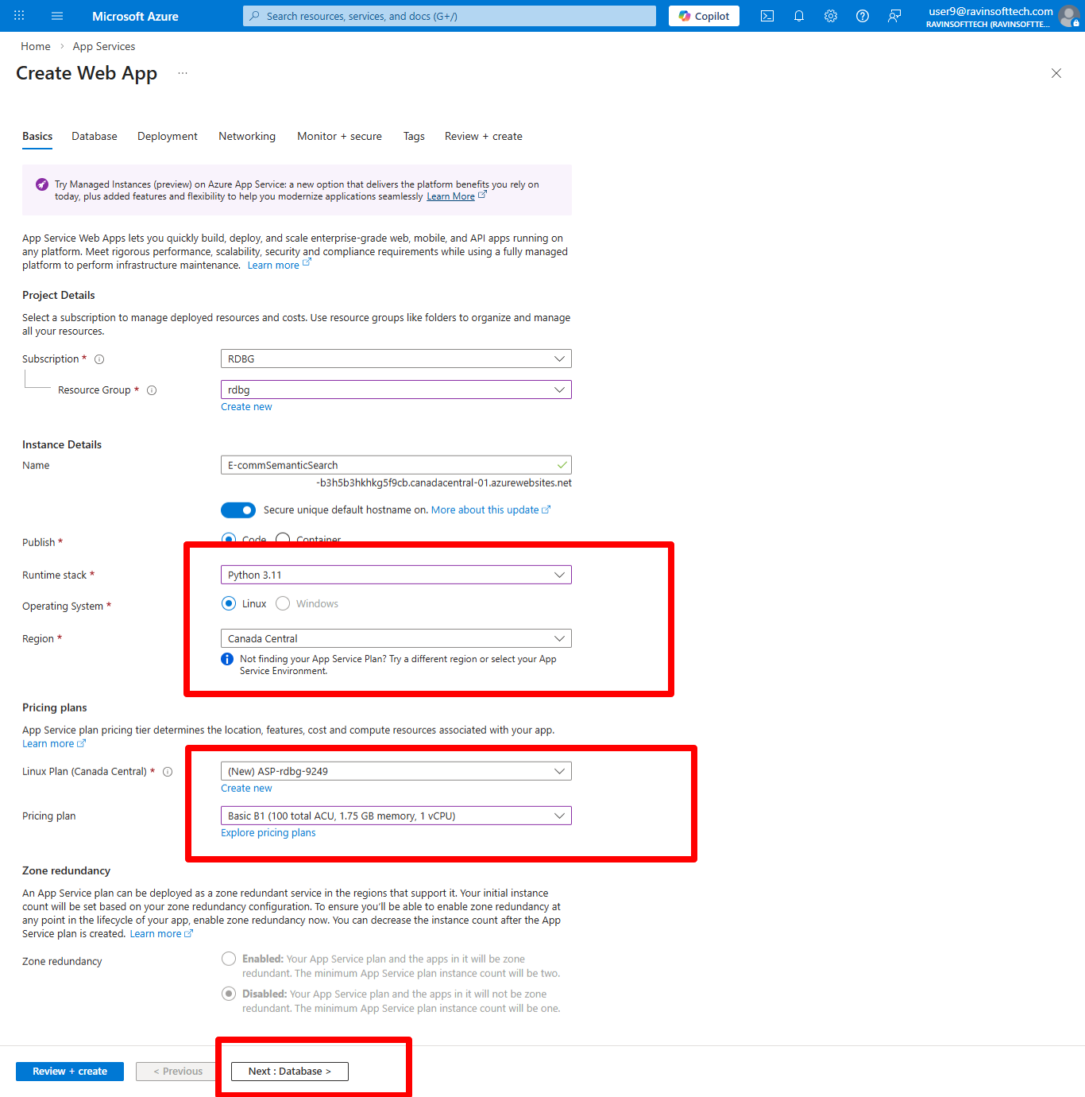
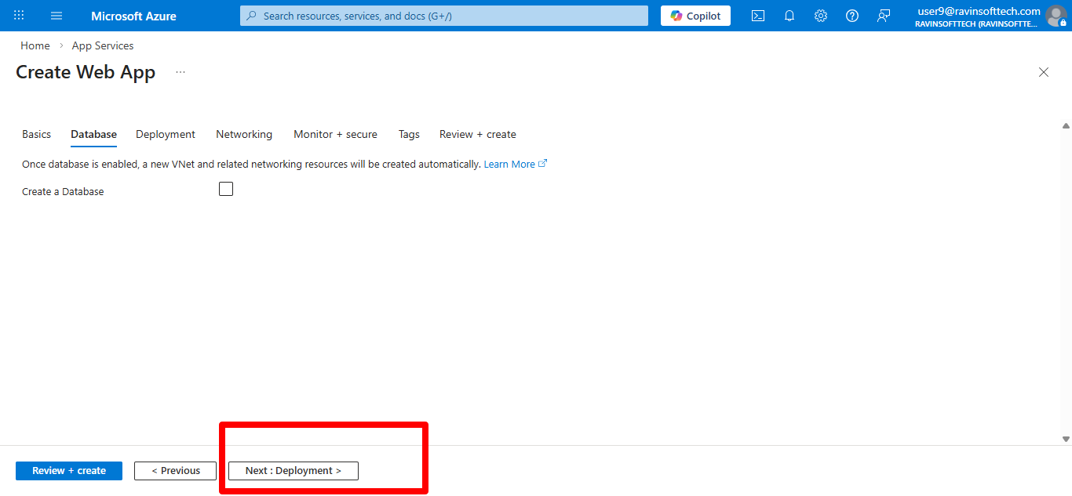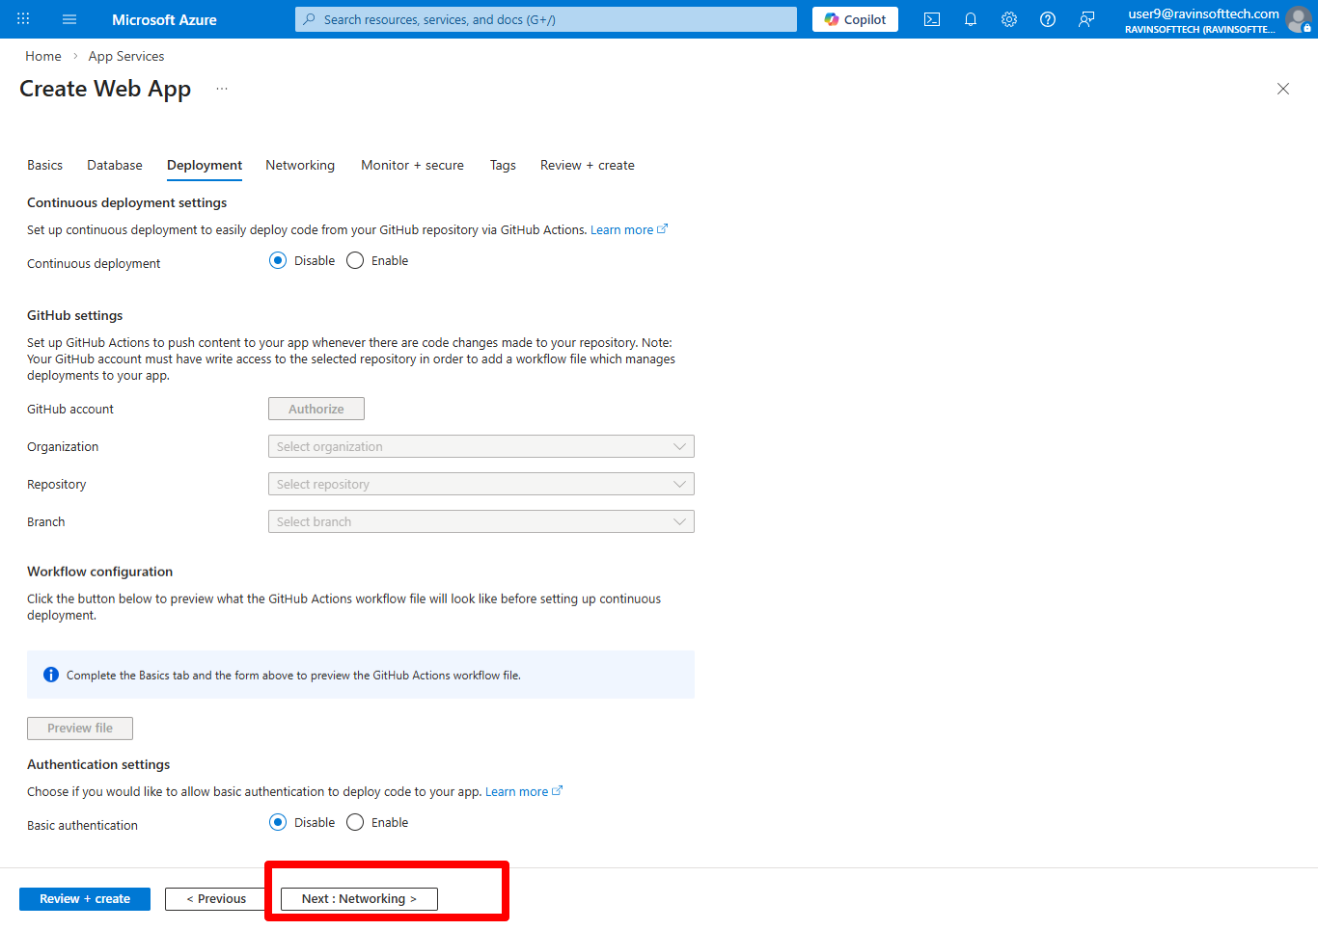
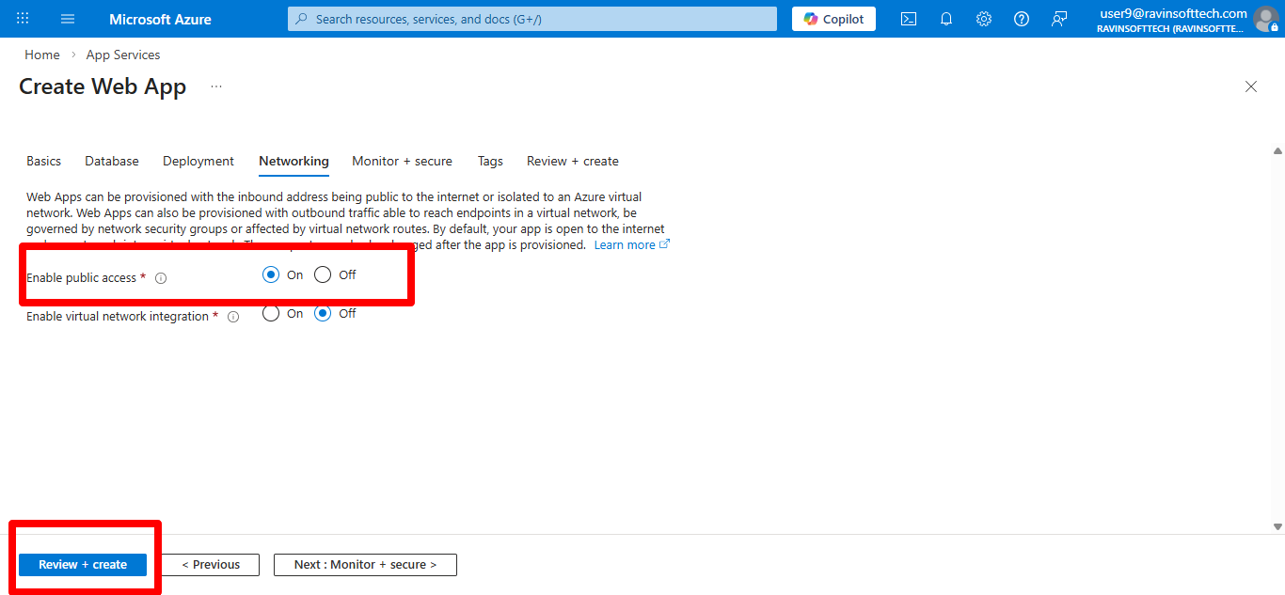
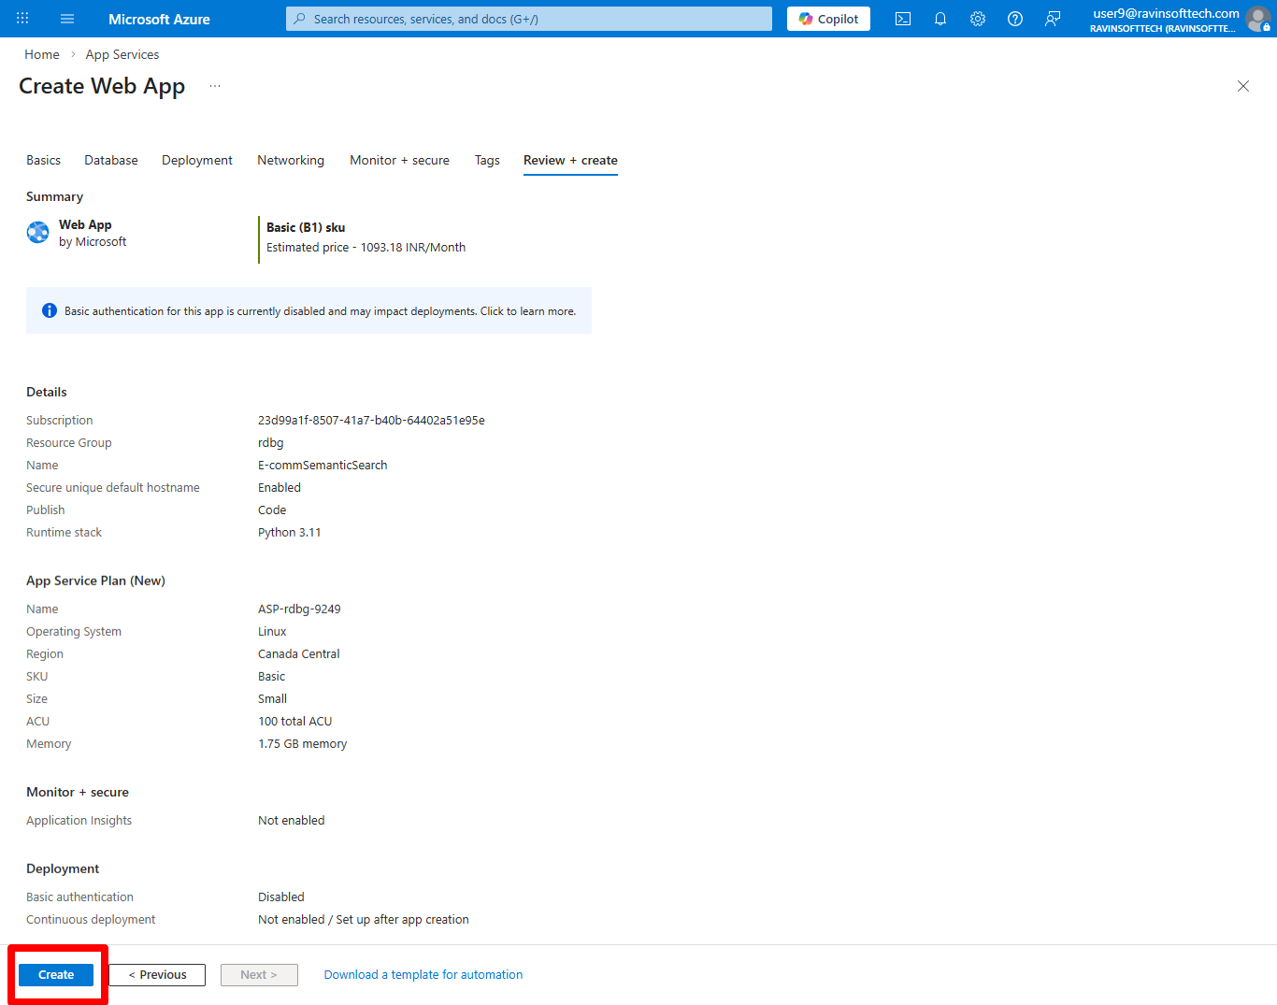

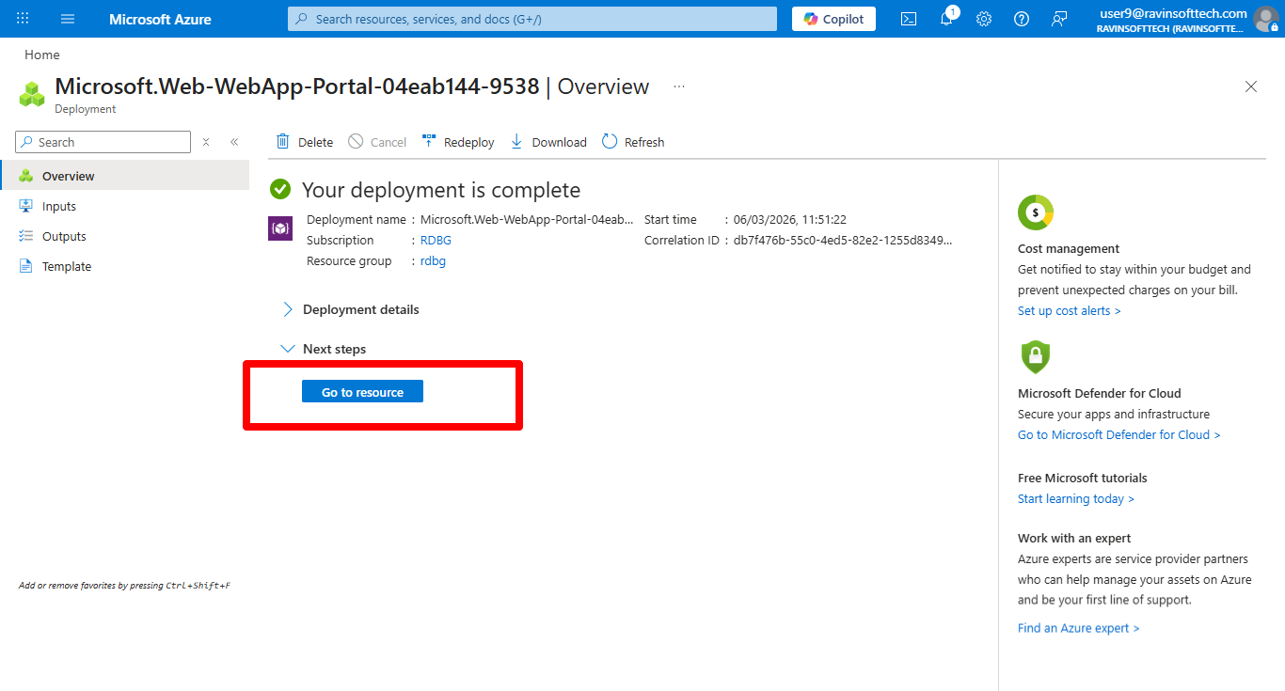

Goto WebApp settings-> configuration ->stack settings->paste startup command.
uvicorn backend.app:app --host 0.0.0.0 --port 8000
Apply the changes .

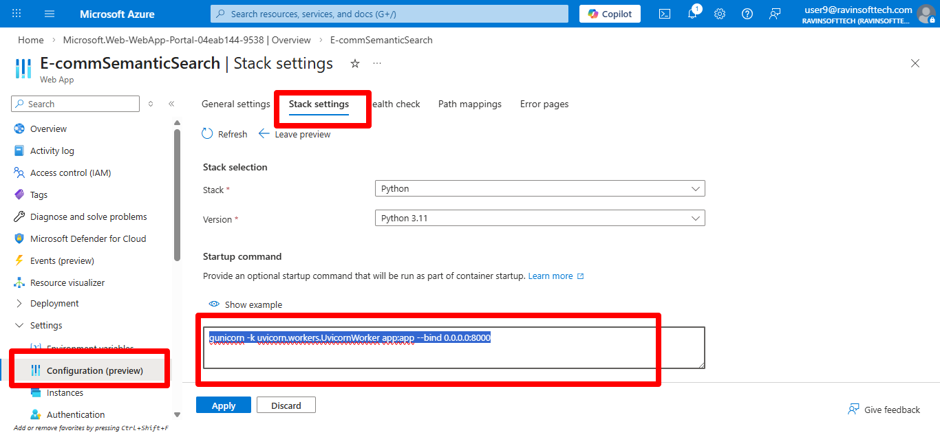
- And goto Environment Variables->App settings->Add SCM_DO_BUILD_DURING_DEPLOYMENT = true
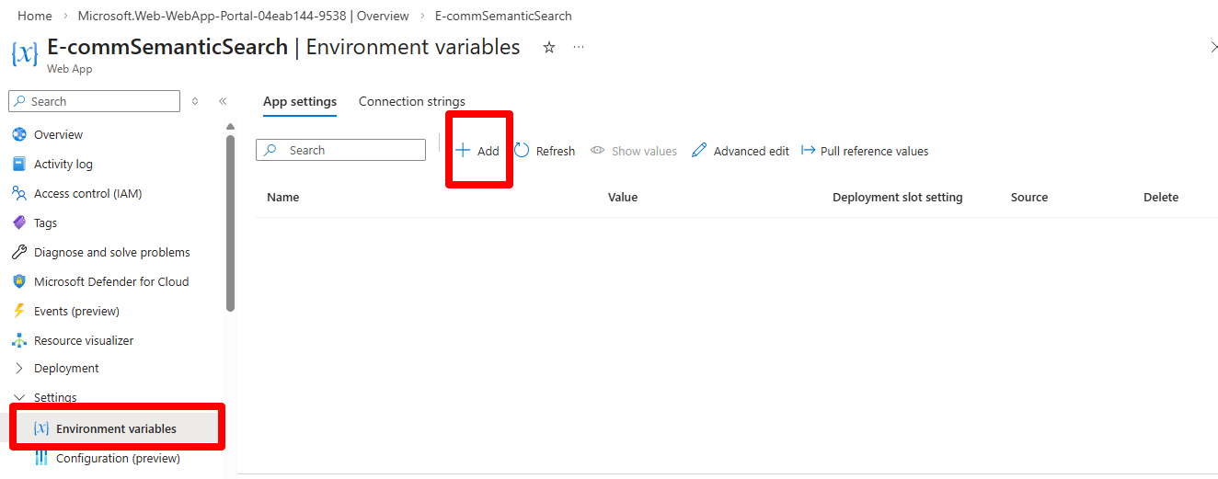

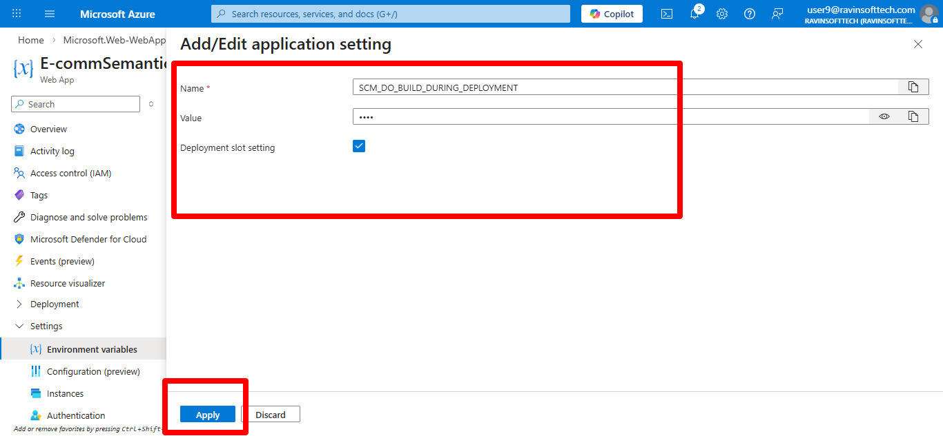
Goto Devops organization, you have given access to Organization.
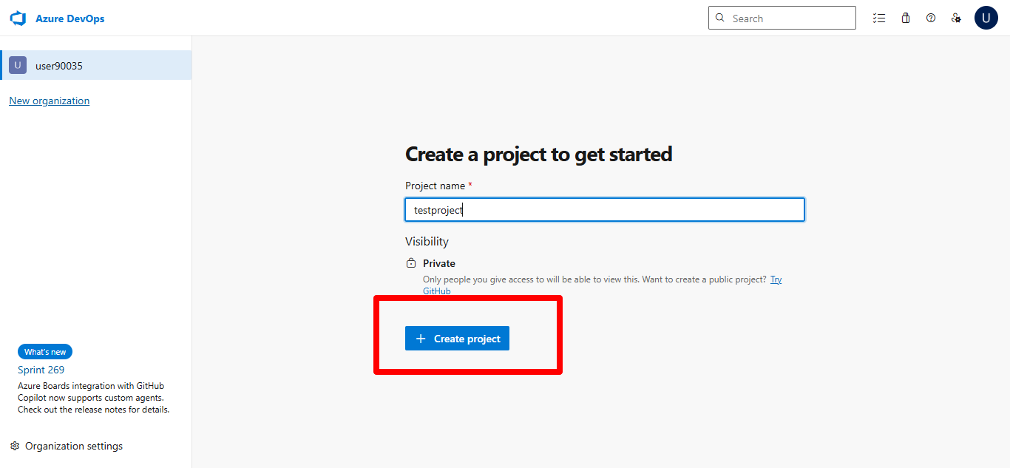
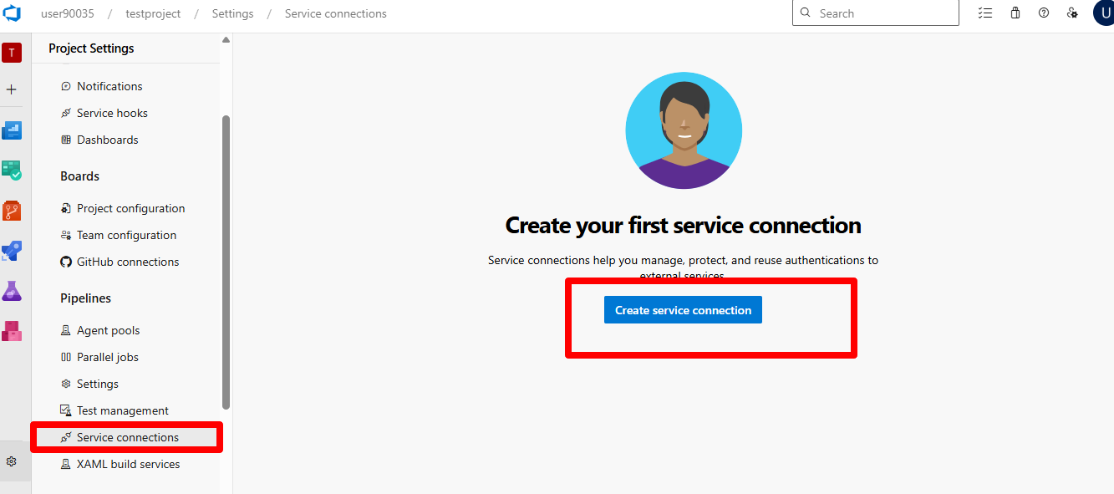

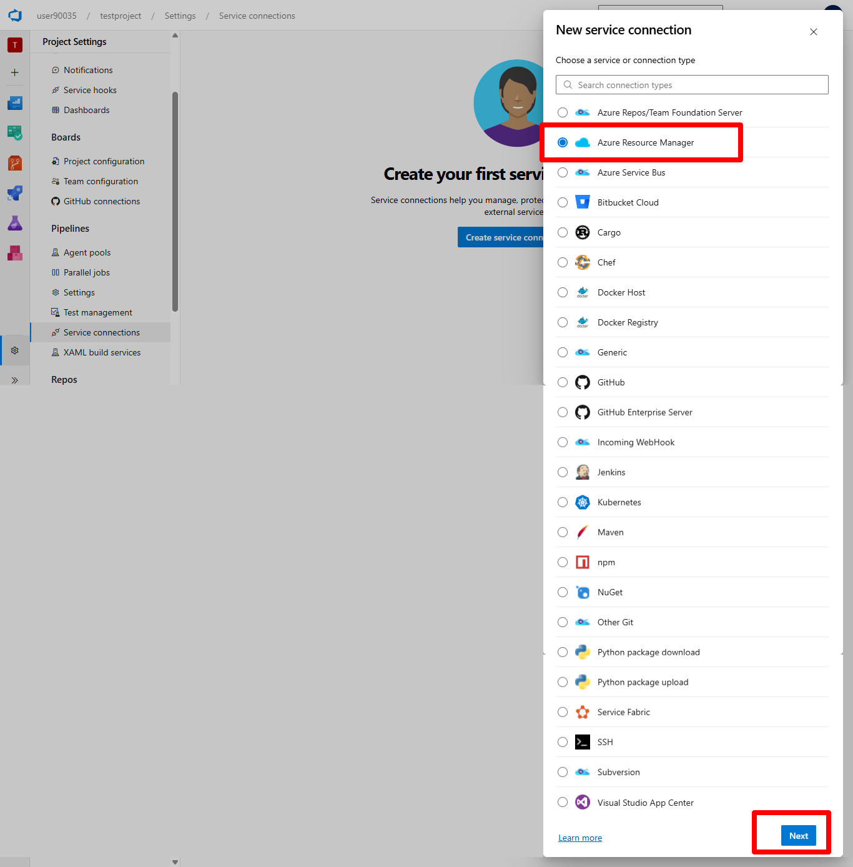
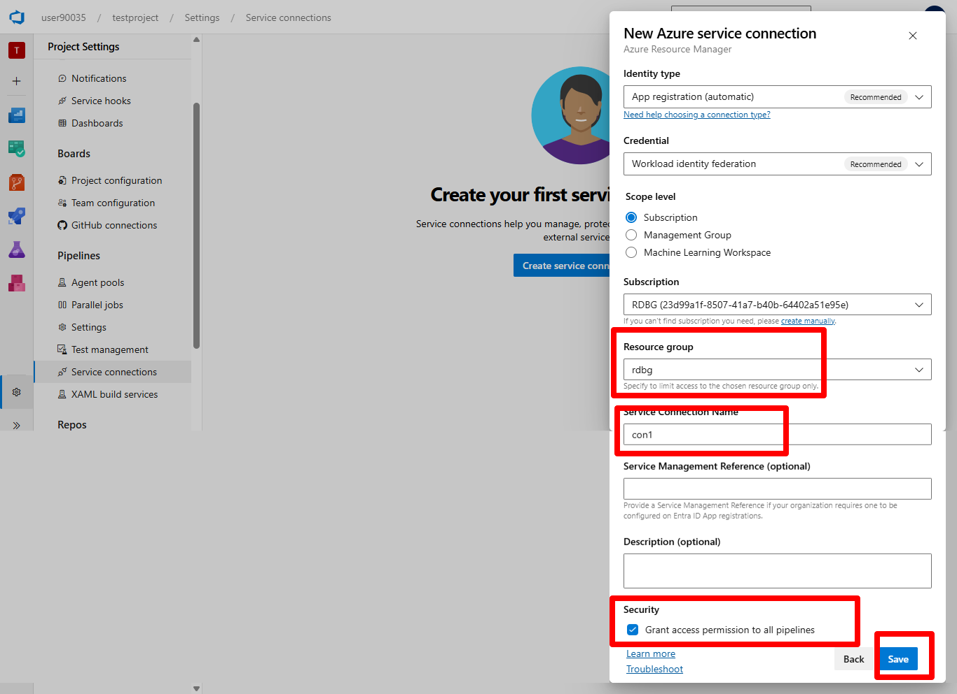
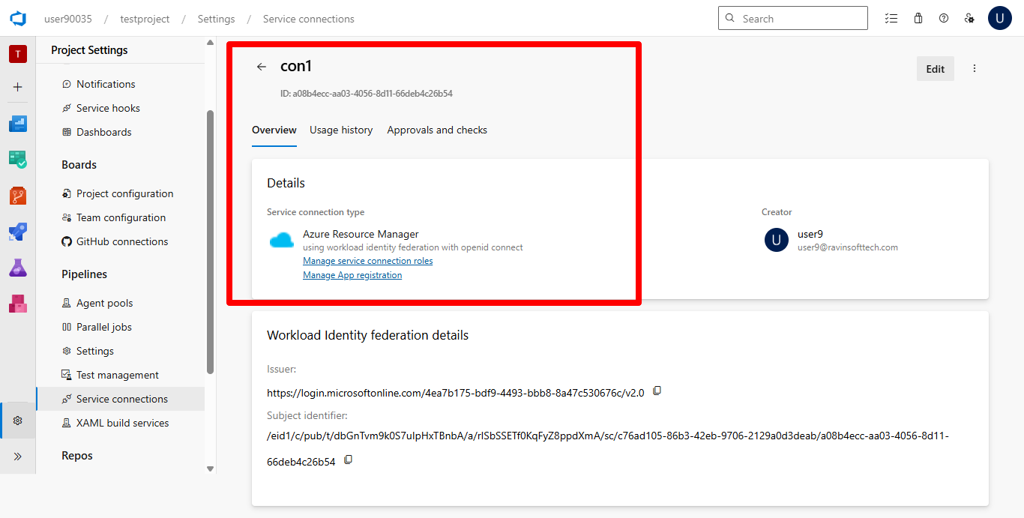
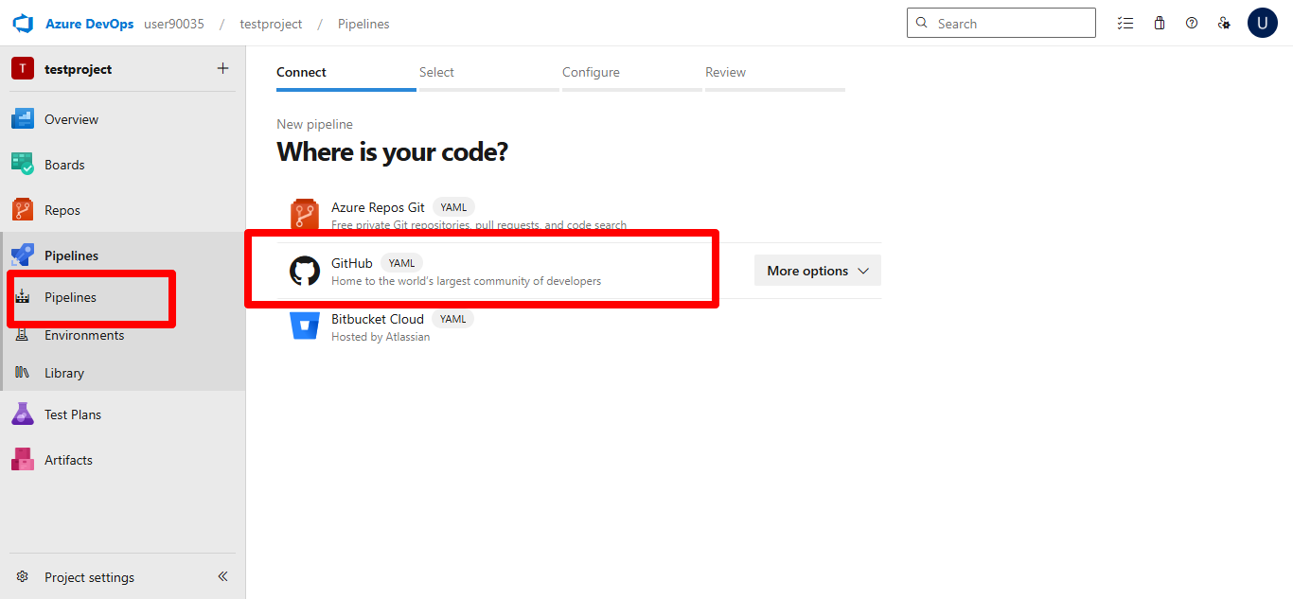
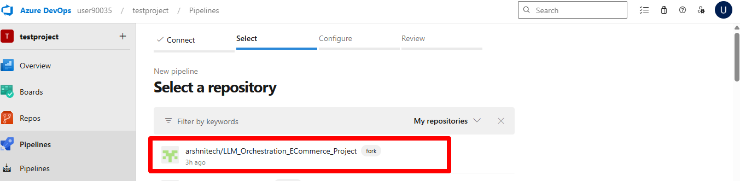
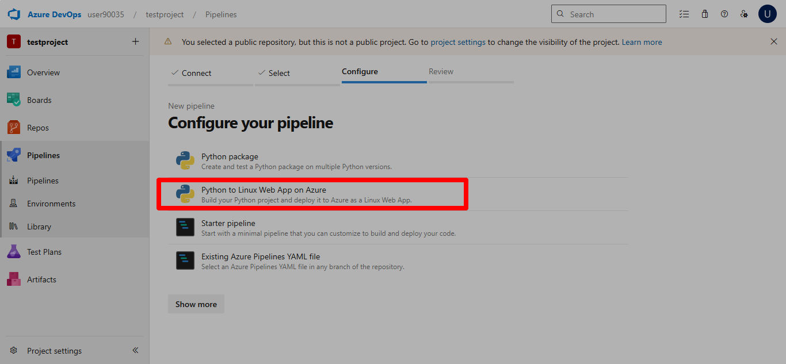
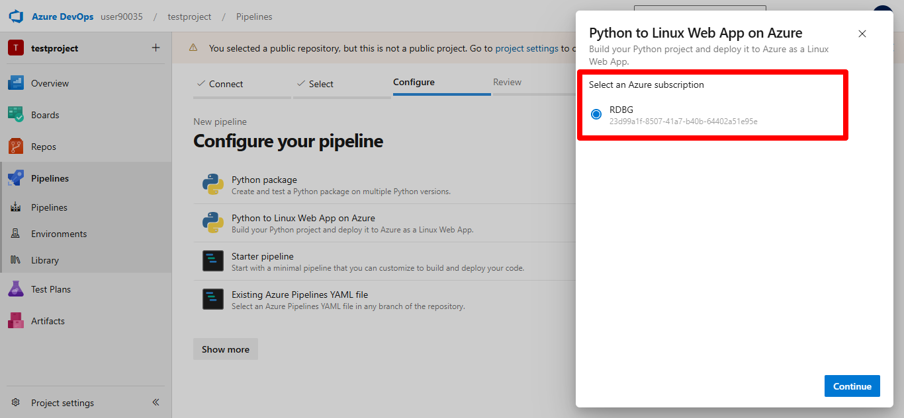
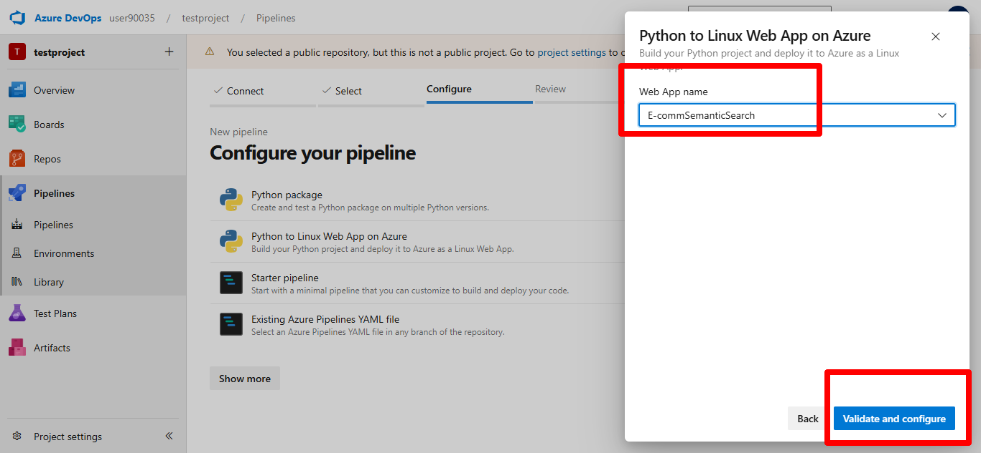

Configure YAML file with
- Service connection id
- App service name
- Agent name

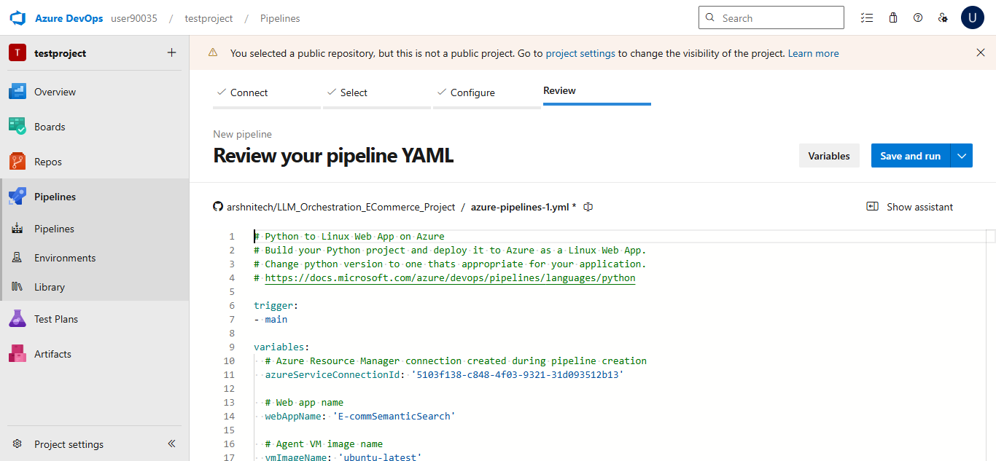

Replace the above azure-pipelines.yml (YAML) file with below and change service connection, App service and Agent details.

trigger:
- main

variables:
azureServiceConnectionId: 'a08b4ecc-aa03-4056-8d11-66deb4c26b54'
webAppName: 'E-commSemanticSearch'
pythonVersion: '3.11'

stages:

- stage: Build
displayName: Build Stage
jobs:
- job: BuildJob
pool:
name: selfhosted-pool # Self-hosted pool

steps:
- script: |
echo Python Version
python --version
displayName: Check Python

- script: |
python -m pip install --upgrade pip
pip install -r requirements.txt
displayName: Install Dependencies

- task: ArchiveFiles@2
inputs:
rootFolderOrFile: '.'
includeRootFolder: false
archiveType: zip
archiveFile: $(Build.ArtifactStagingDirectory)/app.zip
replaceExistingArchive: true
displayName: Archive Files

- publish: $(Build.ArtifactStagingDirectory)/app.zip
artifact: drop

- stage: Deploy
displayName: Deploy Stage
dependsOn: Build
condition: succeeded()

jobs:
- deployment: DeploymentJob
pool:
name: selfhosted-pool # Self-hosted pool again

environment: E-commSemanticSearch

strategy:
runOnce:
deploy:
steps:
- task: AzureWebApp@1
inputs:
azureSubscription: $(azureServiceConnectionId)
appType: webAppLinux
appName: $(webAppName)
package: $(Pipeline.Workspace)/drop/app.zip
after making above changes save and run

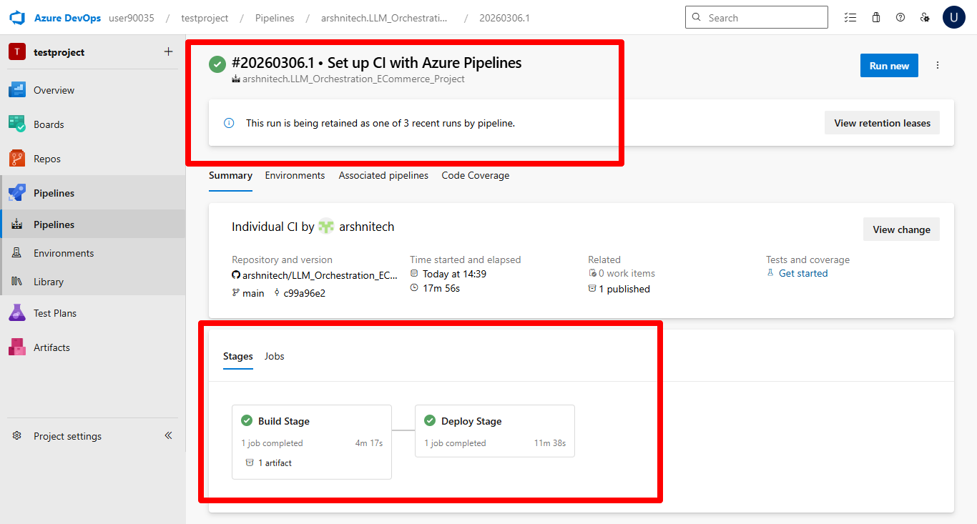
Once deployment is succeeded... it may take 15-20 minutes depending on the application

